Final Examination

01.A. What are the principles of Object Oriented Programming (OOP)? Discuss with example.
(3 marks)
Sol^{n}:
1. Encapsulation → Wrapping data and methods inside a class.
Example:
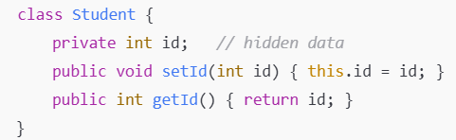
2. Inheritance → A class can use the properties and methods of another class.
Example:
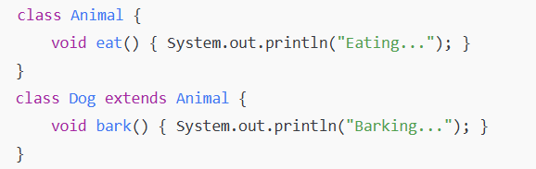
3. Polymorphism → A method can perform different tasks depending on context.
Example:
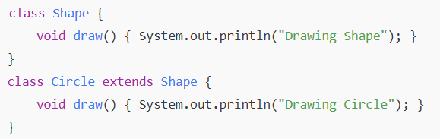
4. Abstraction → Hiding unnecessary details and only showing essential features.
Example:
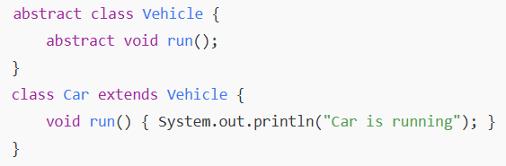

01. B. Write a full java program that will read a person’s weight (kg) and height (meter) and will calculate the Body Mass Index (BMI).
- BMI = weight / height²
If BMI < 18, display “You are underweight”; if BMI > 25 display “You are overweight”; else show “Good. You are fit.”
(5 marks)
Sol^{n}:
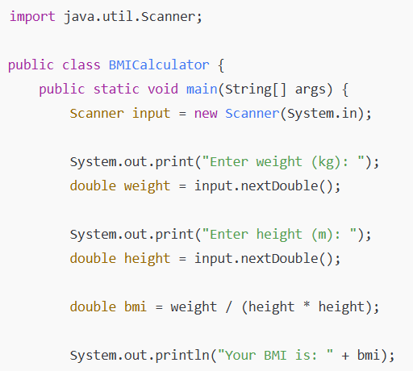
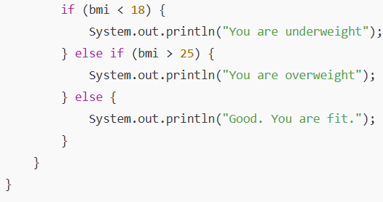
02. A.
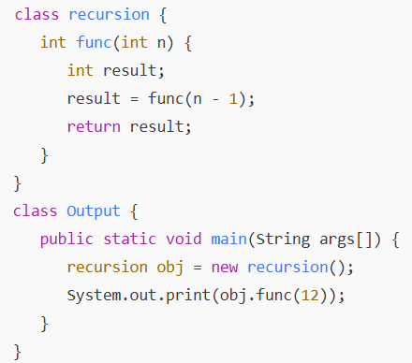
Write the output of the above code with explanation.
(3 marks)
Sol^{n}:
Output:
Explanation:
- The method func(int n) calls itself with func(n - 1).
- But there is no base condition (stopping point).
- This creates infinite recursion → the program keeps calling itself until memory runs out.
- Java will throw a runtime error.

02. A.
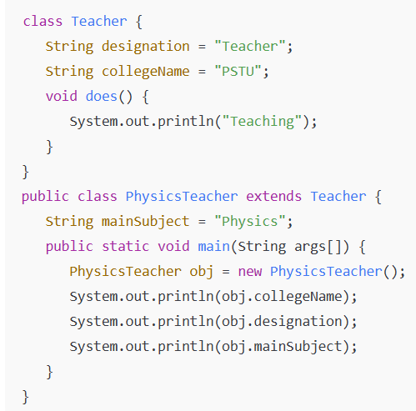
Write the output of the above code with explanation.
(3 marks)
Sol^{n}:
Output:

Explanation:
- PhysicsTeacher extends (inherits) Teacher.
- Therefore, it gets access to:
  - collegeName = "PSTU" (from Teacher)
  - designation = "Teacher" (from Teacher)
- It also has its own property mainSubject = "Physics".
- When printing, the program displays those values.
PSTU
Teacher
Physics
03. A. Difference between Method Overloading and Method Overriding (6 marks)
Sol^{n}:
Feature | Method Overloading | Method Overriding
Definition | Same method name but different parameter list (number/type). | Same method name, same parameter list, but defined in child class.
Inheritance | Not required (can be in same class). | Must involve inheritance (parent → child).
Polymorphism Type | Compile-time polymorphism. | Run-time polymorphism.
Return Type | Can be same or different (with proper rules). | Must be same (or covariant).
Access Modifier | Can be same or different. | Cannot reduce parent method’s visibility.
Binding | Resolved at compile time. | Resolved at run time.

03. B. Describe the meaning of polymorphism in java with example. Differentiate between compile time polymorphism and run time polymorphism in java.
(4 marks)
Sol^{n}:
Polymorphism in OOP is the ability of a single entity (method or object) to take many forms. It allows the same method name to behave differently depending on the context.
Polymorphism in Java is the ability of a method, object, or operator to take many forms. The word "poly" means many and "morphs" means forms. So polymorphism means many forms. In simple terms, it means “one interface, multiple implementations.”
Types:
- Compile-time (Early) Polymorphism → Method Overloading
- Run-time (Late) Polymorphism → Method Overriding
✅ In short: Polymorphism means "one name, many forms".

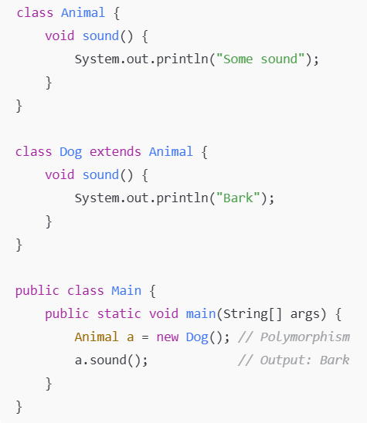
Difference between compile time polymorphism and run time polymorphism in java:
Feature | Compile-time Polymorphism | Run-time Polymorphism
Also called | Method Overloading | Method Overriding
Binding | Early binding (compile time) | Late binding (runtime)
How achieved | Same method name, different parameters | Subclass overrides superclass method
Example | add(int a, int b) and add(double a, double b) | Vehicle.run() overridden by Bike.run()
When resolved | During compilation | During execution

03. C. Compare and contrast abstract classes and interfaces. Why would you use an abstract class? Why would you use an interface?
(5 marks)
Sol^{n}:
------------------------------------------------------------------------------------------------------------------------------------------------------------------------------------------------------------------------------------------------------------

03. D. How multithreading help to increase parallelism in java? Explain with an example.
(5 marks)
Sol^{n}:
------------------------------------------------------------------------------------------------------------------------------------------------------------------------------------------------------------------------------------------------------------

04. A. Explain the purpose of a method parameter. What is the difference between a parameter and an argument?
Sol^{n}:
The purpose of method parameter is passing values or data into a method so that the method can use those values while executing its task.
A parameter is a variable defined in a method’s declaration, while an argument is the actual value we pass to that parameter when calling the method.
A parameter is a variable defined in a method’s signature to receive data. An argument is the actual value passed to the parameter when the method is called.

04. B. One of the world’s most common objects is a wrist watch. Discuss how each of the following terms and concepts applies to the notion of a watch: object, attributes, behaviors, class, inheritance (consider, for example, an alarm clock), modeling, messages, encapsulation, interface and information hiding.
(5 marks)
Sol^{n}:
Concept | Application to a Watch
Object | A specific watch you own is an object.
Attributes | Color, brand, hour, minute, second, battery level.
Behaviors | Telling time, setting alarm, stopwatch function.
Class | General blueprint “Watch” defining all watches.
Inheritance | AlarmClock class can inherit from Watch, adding alarm feature.
Modeling | Designing a Watch class models a real-world watch in software.
Messages | Calling a method like watch.setTime(10,30) sends a message to the watch object.
Encapsulation | Hiding internal state like battery level; access via methods only.
Interface | Expose methods like getTime(), setAlarm() to interact with the watch.
Information Hiding | Prevent direct modification of internal data like hour without proper methods.

04. C. Write method distance to calculate the distance between two points (x1, y1) and (x2, y2). All numbers and return values should be of type double. Incorporate this method into an application that enables the user to enter the coordinates of the points.
(3 marks)
Sol^{n}:
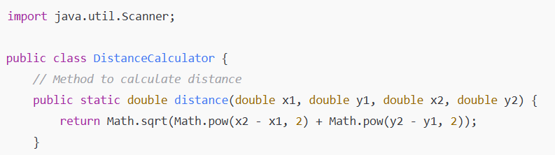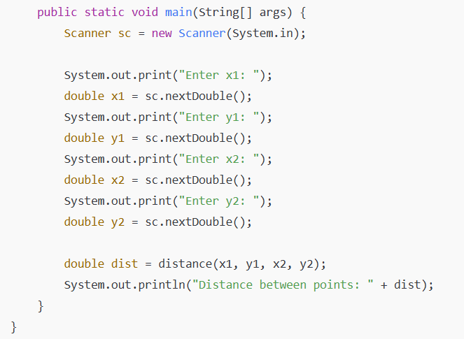

04. D. An integer number is said to be a perfect number if its factors, including 1 (but not the number itself), sum to the number. For example, 6 is a perfect number, because 6 = 1 + 2 + 3. Write a method isPerfect that determines whether parameter number is a perfect number. Use this method in an application that displays all the perfect numbers between 1 and 1000. Display the factors of each perfect number to confirm that the number is indeed perfect. Challenge the computing power of your computer by testing numbers much larger than 1000.
(4 marks)
Sol^{n}:
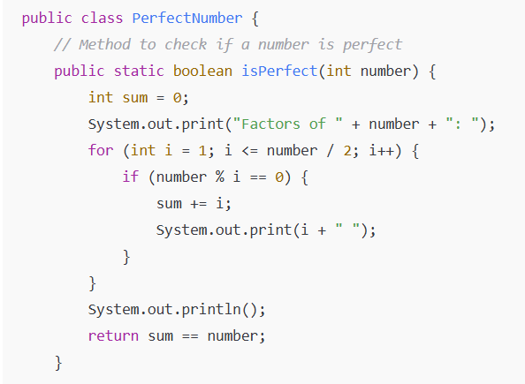
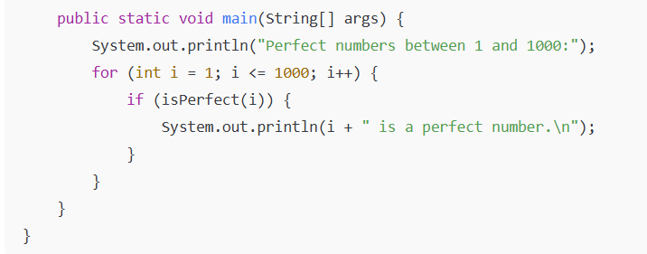
Explanation:
- Loop through numbers from 1 to 1000.
- Find all factors except the number itself.
- Sum them and check if sum equals the number.
- Prints factors and confirms perfection.

05. A. Define Constructor. What happens when a return type, even void, is specified for a constructor? How garbage collector works in JAVA?
(3 marks)
Sol^{n}:
A constructor is a special method in Java used to initialize objects. It has the same name as the class and does not have a return type (not even void).
If you write a return type (even void), it becomes a regular method, not a constructor. The compiler will treat it as a normal method.
Garbage Collector (GC) automatically reclaims memory by destroying objects that are no longer reachable in the program.

05. B. What are overloaded constructors? Describe with an example.
(4 marks)
Sol^{n}:
Constructor overloading means having more than one constructor in a class with different parameter lists. This allows objects to be initialized in multiple ways.
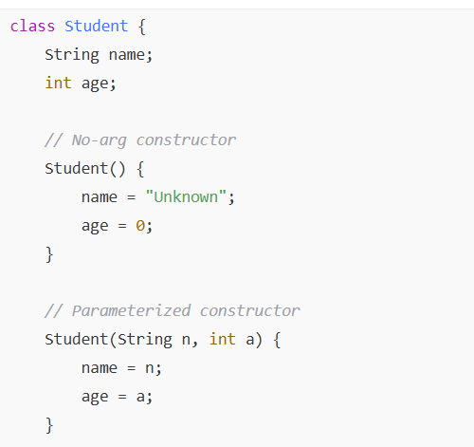
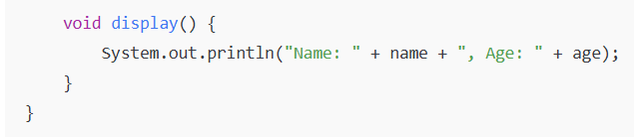
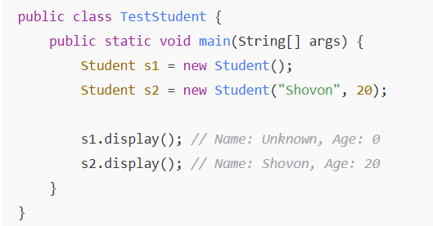

05. C. Create class SavingsAccount. Use a static variable annualInterestRate to store the annual interest rate for all account holders. Each object of the class contains a private instance variable savingsBalance indicating the amount the saver currently has on deposit. Provide method calculateMonthlyInterest to calculate the monthly interest by multiplying the savingsBalance by annualInterestRate divided by 12—this interest should be added to savingsBalance. Provide a static method modifyInterestRate that sets the annualInterestRate to a new value. Write a program to test class SavingsAccount. Instantiate two SavingsAccount objects, saver1 and saver2, with balances of 2000.00 and 3000.00, respectively. Set annualInterestRate to 4%, then calculate the monthly interest for each of 12 months and print the new balances for both savers. Next, set the annualInterestRate to 5%, calculate the next month’s interest and print the new balances for both savers.
(6 marks)

Sol^{n}:
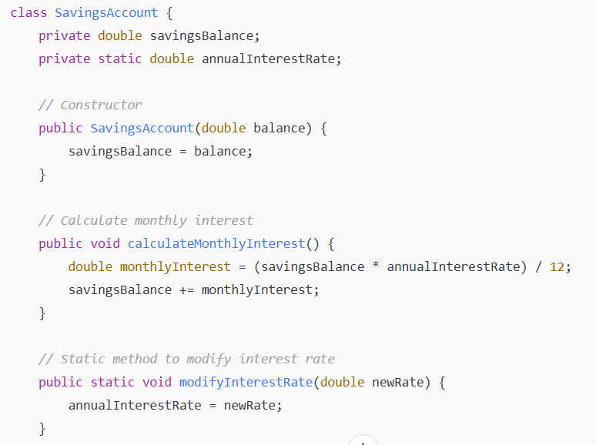
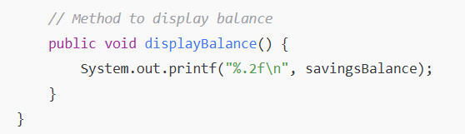
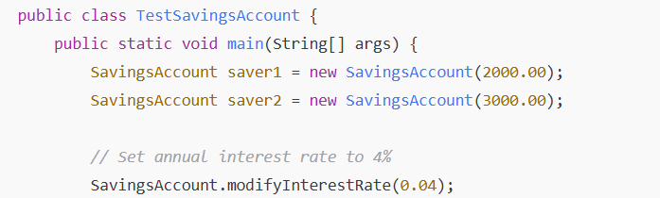
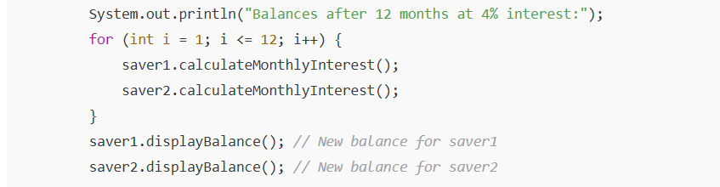
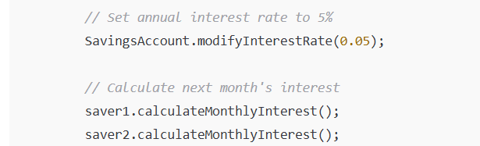
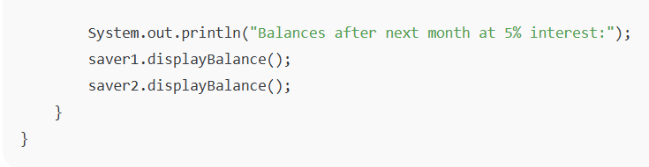

06. A. Why are exceptions particularly appropriate for dealing with errors produced by methods of classes in the Java API? If no exceptions are thrown in a try block, where does control proceed to when the try block completes execution?
(3 marks)
Sol^{n}:
------------------------------------------------------------------------------------------------------------------------------------------------------------------------------------------------------------------------------------------------------------

06. B. What is the key reason for using finally blocks? Write java code to create a java file and perform read-write to that file?
(4 marks)
Sol^{n}:
------------------------------------------------------------------------------------------------------------------------------------------------------------------------------------------------------------------------------------------------------------

06. C. Write short note about
a) Iterator
b) Autoboxing
c) ArrayList
d) Auto-unboxing
e) Set
f) Collection.
(3 marks)
Sol^{n}:
------------------------------------------------------------------------------------------------------------------------------------------------------------------------------------------------------------------------------------------------------------

06. D. Define a data-manipulation application for the books database. The user should be able to edit existing data and add new data to the database (obeying referential and entity integrity constraints). Allow the user to edit the database in the following ways:
a) Add a new author.
b) Edit the existing information for an author.
c) Add a new title for an author (Remember that the book must have an entry in the AuthorISBN table).
d) Add a new entry in the AuthorISBN table to link authors with titles.
(4 marks)
Sol^{n}:
------------------------------------------------------------------------------------------------------------------------------------------------------------------------------------------------------------------------------------------------------------

